Word Break
Problem Statement: Given a string s and a dictionary of strings wordDict, return true if s can be segmented into a space-separated sequence of one or more dictionary words otherwise return false.
Examples
Example 1:
Input: s = "takeuforward", wordDict = ["take", "forward", "you", "u"]
Output: true
Explanation: Return true because "takeuforward" can be segmented as "take", "u", "forward".

Example 2:
Input: s = "applepineapple", wordDict = ["apple"]
Output: false
Explanation: Return false because "applepineapple" can be segmented as "apple", "pine", "apple" but "pine" is not in the dictionary.
Algorithm
- Set Initialization: Convert wordDict into a set for O(1) word lookup.
- DP Array: Create a boolean DP array dp of size n + 1, where dp[i] indicates whether the substring s[0..i-1] can be segmented using the dictionary.
- Max Word Length: Compute the length of the longest word in the dictionary to restrict how far back we look from each position i.
- Main Loop: For each position i in the string:
  - Loop backwards from i - 1 to max(i - maxWordLength, 0).
  - If dp[j] is true and s[j:i] is in the dictionary, mark dp[i] as true and break early.
- Return Result: Return dp[n] as the final answer, where n is the length of the string.
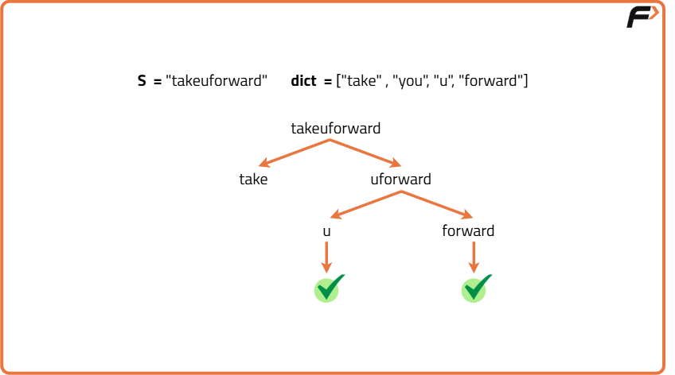
Code
import java.util.*;
class Solution {
// Function to check if the string can be segmented
public boolean wordBreak(String s, List<String> wordDict) {
int n = s.length();
Set<String> dict = new HashSet<>(wordDict);
boolean[] dp = new boolean[n + 1];
dp[0] = true; // Empty string is always "segmented"
int maxLen = 0;

// Find the maximum length of words in the dictionary
for (String word : wordDict) {
maxLen = Math.max(maxLen, word.length());
}

// DP to check if the string can be segmented
for (int i = 1; i <= n; ++i) {
for (int j = Math.max(0, i - maxLen); j < i; ++j) {
if (dp[j] && dict.contains(s.substring(j, i))) {
dp[i] = true;
break; // Early termination when we find a valid word
}
}
}

return dp[n]; // Return if the entire string can be segmented
}
}
Complexity Analysis
Time Complexity: O(n \* m), where n is the length of `s` and m is the average length of words in `wordDict`. The inner loop now runs over a limited range due to the word lengths.
Space Complexity: O(n), for the DP array and the set used for dictionary lookup.

